Town of Rolling Hills

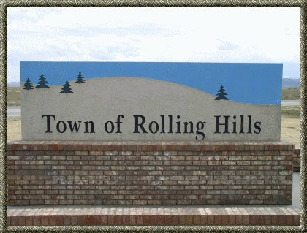

Strategic Growth Plan
January 2024

Current State Assessment
Conduct a thorough assessment of the municipality’s current state, including analyzing strengths, weaknesses, opportunities, and threats. Identify key areas that need improvement and determine the overall vision and mission for the municipality.
Vision
The Town of Rolling Hills will provide a community in which people will want to move to and stay in.
Mission
It is the mission of the Town of Rolling Hills to provide quality water and roads, and to provide a community that offers a welcoming environment and activities while keeping with a rural nature setting.

Stakeholders
Involve staff, citizens, and other stakeholders in the planning process to ensure everyone understands how they fit into the municipality’s strategic plan.
Goals and Objectives
Set concrete goals and objectives to drive progress and improvement. Be sure to include a mix of things the municipality does well and things it doesn’t do well, so citizens can see that the municipality has a good perspective on what is going well and what is not going well within the community.
Strategies and Tactics
Develop effective strategies and tactics to reach the goals and objectives set in step 3. This may involve allocating resources strategically to maximize impact and efficiency.
Implement and Monitor
Once the plan is developed, roll it out to city departments to execute their individual responsibilities. Monitor progress and adjust the plan as needed.
Tools and Templates
Consider using a strategic planning template or software to help guide the process and keep everyone on track. For example, ClickUp offers a Municipality Strategic plan Template that can help municipalities set clear goals and priorities.
Remember that a strategic plan is not static and should be periodically reviewed and updated to ensure it still aligns with current issues, challenges, and realities. By involving stakeholders, municipality can create a strategic plan that guides decision-making and helps move the community toward a better future.

