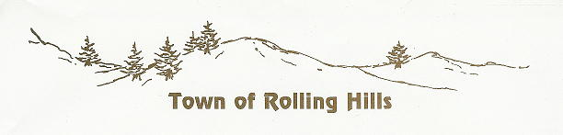

Mayor  Jon Maines  Clerk / Treasurer  Teresa Montgomery | 38 South Badger Road  Rolling Hills, WY 82637  307.277.6660  tmontgomery@rollinghillswy.org  www.rollinghillswy.org | Council  Lori Cielinski  Donna Weaver  Anthony Rivera  Ken Montgomery

November 7, 2023

Tory Walsh, Special Projects Coordinator
Converse County Special Projects Office
107 North 5th Street, B-6
Douglas WY 82633

Re: Subdivision Permit Application
Applicant: Mickey David Farrar

Dear Ms. Walsh -

The Governing Body for the Town of Rolling Hills has reviewed the above-referenced Subdivision Permit Application and preliminary plat and finds no objection to this project. Please consider this letter as the Town’s approval of the application.

If you need anything further regarding this matter, please let me know.

Regards,

Teresa Montgomery, Clerk / Treasurer
for the Town of Rolling Hills

